3.80: a) The drops are given as falling vertically, so their horizontal component of velocity with respect to the earth is zero. With respect to the train, their horizontal component of velocity is 12.0 m/s, west (as the train is moving eastward). b) The vertical component, in either frame, is 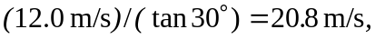 and this is the magnitude of the velocity in the frame of the earth. The magnitude of the velocity in the frame of the train is 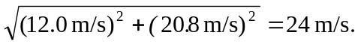 This is, of course, the same as 